**Laboratory 2: Measuring Voltage and Current, Verification of Ohm’s and Kirchhoff’s Laws**

Austin Page

Mitchell Hicks

Taha Hashmat

**Objective:**

The objective of this lab was to introduce Electric Circuit students to testing using the digital multimeter, so that we could test Ohm’s Law as well as Kirchhoff’s Voltage Law and Kirchhoff’s Current Law.

**Components and Instruments Used:**

Throughout this lab we had used a variety of different tools and components. These include:

* Advanced breadboard
* DT Digital Multimeter
* Power Supply
* Resistors (many different types)
* Connecting wires/cables

**Procedure:**

In this lab, we had to do numerous tasks to test Kirchhoff’s Voltage and Current Laws, as well as Ohm’s Law. We started by testing a 4.7k Ohm resistor with different voltage inputs, and graphed the relationship of V and I (pictured below). In the second part of the lab, we had to build circuits given to us and determine current and voltage values across different parts of the circuit, using either mesh analysis or nodal analysis. Using these measured values, we cross-referenced them with the calculated values from the pre-lab to confirm KVL and KCL.

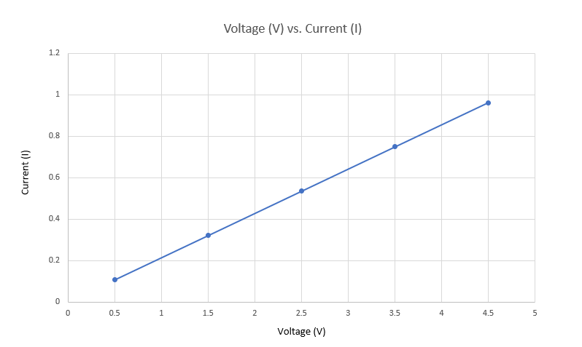

**Results:**

Throughout the tests, we saw very small percentage error, with the average being less than 1%. We were quick to realise how the laws worked, and were amazed by the precision of the laws.

**Summary and Discussion:**

Overall, this lab was a very interesting insight into confirming calculations and laws. I think what we learned and practiced gives students a great way to test information they’ve calculated when studying, especially it they want to further solidify their knowledge on circuits. Having new learned knowledge and experience with Multism and knowing how to properly wire parallel and series circuits will allow me to cross reference my future calculations to make sure I am precise and correct.